What should you report?
Any adverse incident which has the potential to produce unexpected or unwanted effects; or any incident which has a consequence or learning point. i.e., An event that causes a loss, injury or a near miss to a patient, staff or others.
Example inicidents that should be reported:
Clinical Issues – Medication, poor transfers of care, infection issues, medical device failure, delays in treatment, unexpected outcomes, pressure sores.
Environmental Issues – Accidents, violence and aggression.
Professional Issues - Records, breaches of confidentiality, standards.
Why should you report an incident?
By reporting an incident you are creating an official ‘record of the event’, and the details can be recalled and referred to in the future. The analysing of incidents enables us to learn from events, develop and improve services and monitor themes and trends.
How do you report?
Most computers will have access to Datix via the Datix icon  , if you haven’t got this you can go to:
Datix: Log in to Datix (thirdparty.nhs.uk)
You can then save the link as an icon on your desktop.
You DO NOT need a Datix login or password to report an incident.

Each area requires the information as identified, to commence click on new form in the top left corner
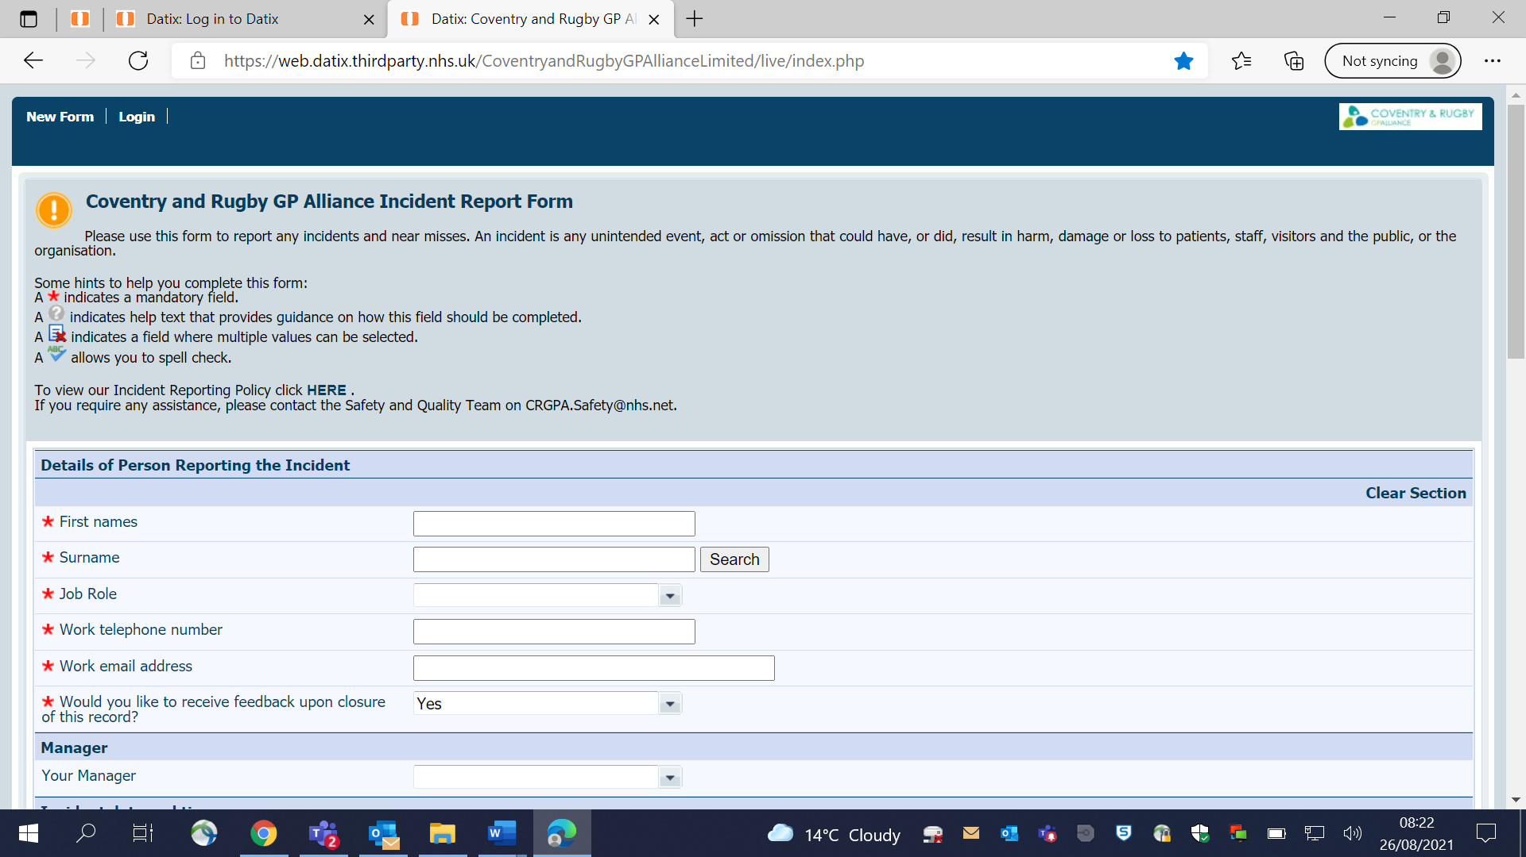
* Indicates areas where information is required in order to submit the incident form.
Section 1
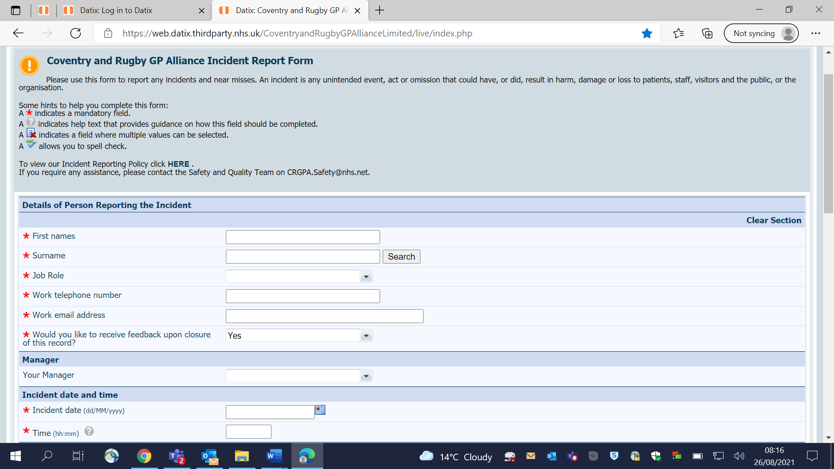
Section 2 – The Incident
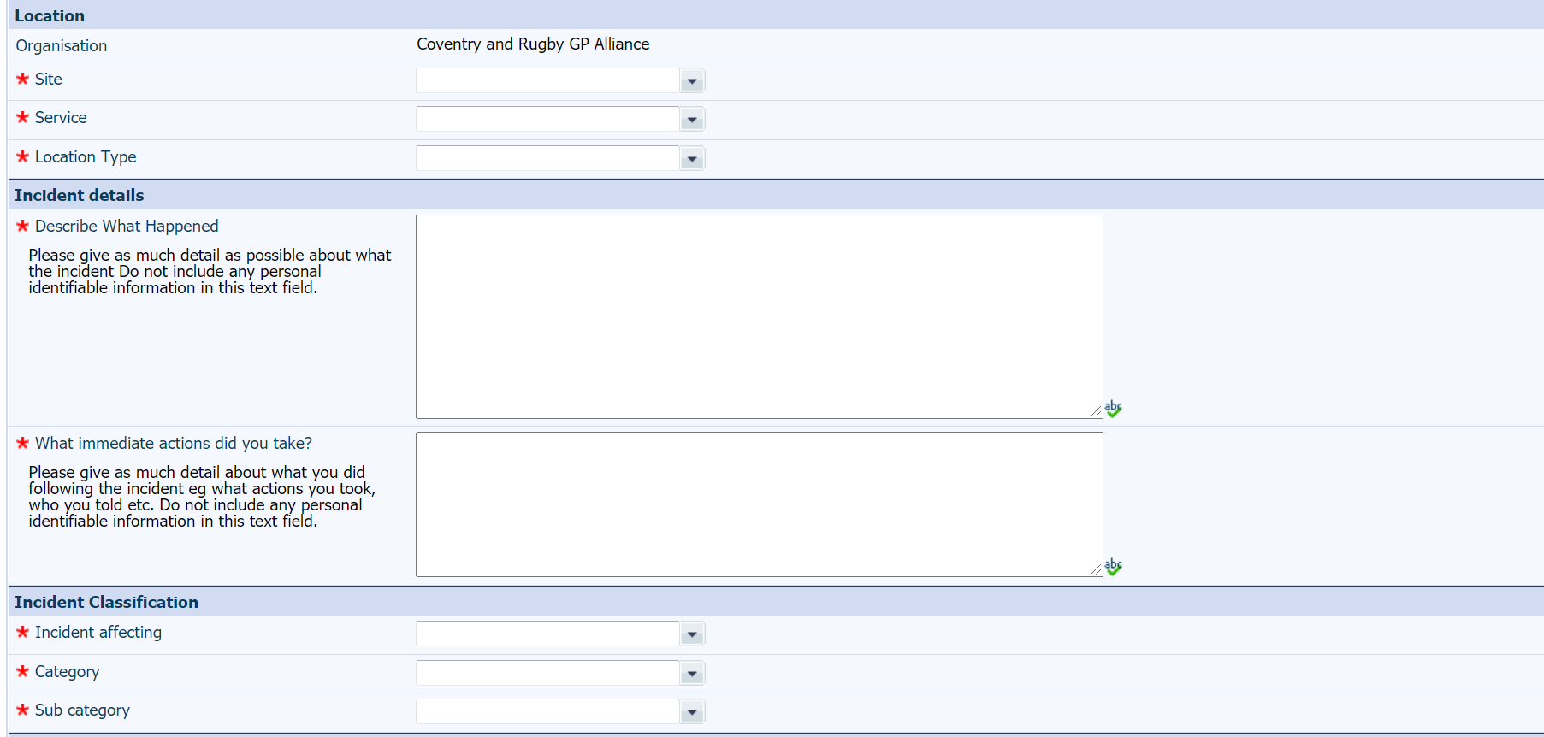

Section 3 – Result and information
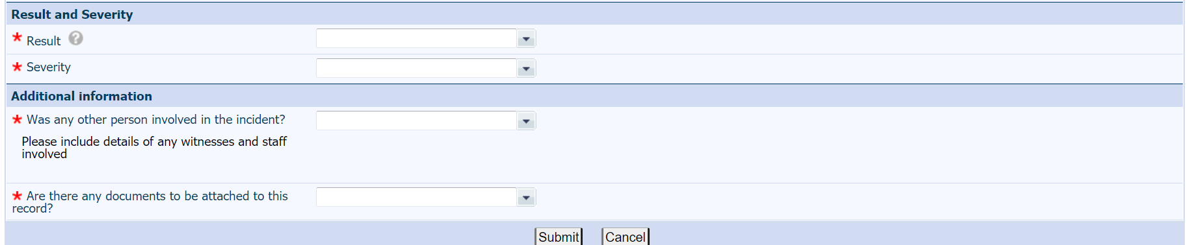
Following completion – then submit and this will generate automated messages for review.

