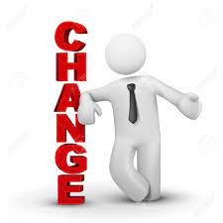
One of the constant battles our Mind deals with on a daily basis, is Change. This can be an expected Change such as the weather, simple Changes like home decor, or bigger Changes. It is the only constant in life, the only thing we can be sure will happen.

Change affects us all and we all deal with it differently. It sometimes brings fear during challenging and unexpected life events however, it can also bring hope.

No matter the Change we experience, how we embrace that Change will forever impact how we are able to live with the Change.

The Change House is a great way to understand emotions we all experience in response to Change:

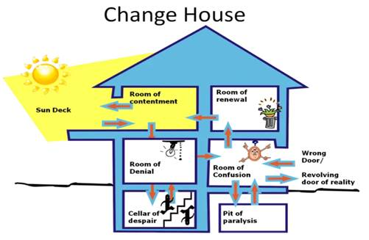
- Room of contentment is a mindset where we are content with what we have and how our life is progressing.
- Room of denial is when change first occurs and we initially believe that it wouldn’t affect us or does not apply to us.
- Cellar of despair is the dungeon of denial. We sometimes get stuck in our denial and end up burying our heads in the sand hoping that everything that’s upsetting us will go away.
- Room of confusion – is where we start to realise that something is different, but we still do not know how to respond appropriately to it. like the room of denial, the room of confusion also has a dungeon, which is...
- Pit of Paralysis is the dungeon we go to when there is simply too much to consider, we become overwhelmed with options of how to respond to change. we end up doing nothing.
- During our journey through the Change House, we can sometimes end up in wrong decisions room.
- Room of renewal is where we ultimately make up our minds, form a plan and a new way forward and we feel empowered to invigorate to move on.

The Personal Transition Curve shows how we feel and reach while going through the Change House. While it is natural to feel anxious, afraid, disappointed or depressed during change, we must take steps to move up the transition curve. If we stay in the negative or depressed state too long, it can become an addictive behaviour and we may accept that transition stage as the new reality and stop trying to progress further on the transition curve.

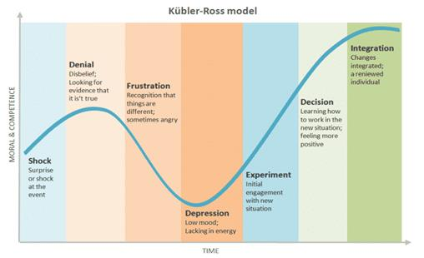
As Change is a constant, our transition process through different emotions and rooms is also constant. This is a never-ending cycle. Once we have settled again, we find ourselves dealing with another situation or Change. We should therefore practice acceptance and live with an attitude of gratitude and embrace Change as an opportunity for continuous renewal and growth. We learn it, embrace it, accept it and apply it!

And lastly, we must remember that we are all going through multiple changes at the same time:
Changes at Work  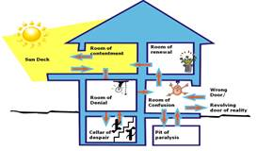 | Changes in Relationships  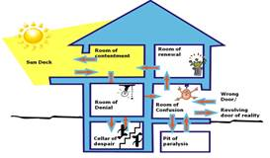
Changes in Health  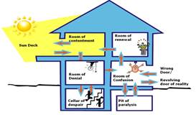 | Changes in Personal Circumstances  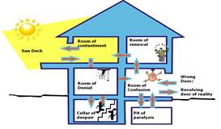
Changes in Law, Government  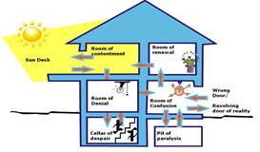 | World crisis and pandemics  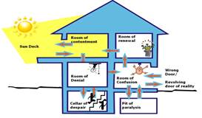

So, remember to be kind to one another.

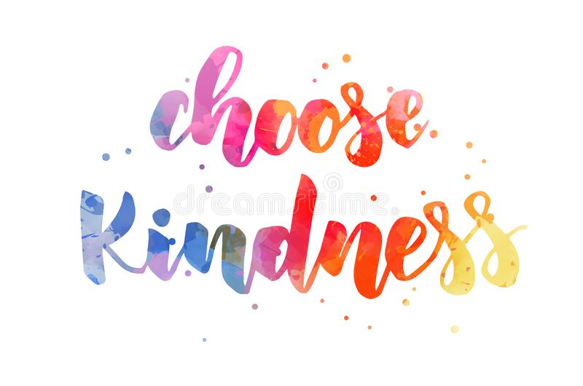

Kindness isn’t just one of our organisational values. It is the most powerful agent of positive change. We can all show kindness to our colleagues by little gestures like:
- Making our colleagues a cup of coffee
- Offering help when we see one of our colleagues not having a great day
- Always acknowledging receipt of messages
- Relay the positive feedback we hear about someone’s work if they weren’t present
- Thank your teams for their hard work and support
- Celebrate the small wins
