So, Change! ... it feels like a week is not enough to capture just how and how much life changes can impact our Mind or Mental Wellbeing. We are in a constant transition in work and relationships, in physical and mental health, in our private and social life. Sometimes we know or anticipate a change and other times it catches us off-guard in a form of a disappointment or a wonderful surprise.

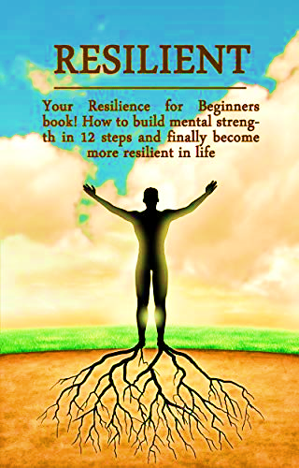
Learning to cope with change can have positive effects on our health and relationships. This ability to cope with change is called Resilience. There are many definitions of resilience, including:
‘the ability of a substance or object to spring back into shape’
‘resilience is the process of adapting well in the face of adversity, trauma, tragedy, threats or even significant sources of stress such as family and relationship problems, health issues, workplace and financial stressors. It means bouncing back from difficult experiences.’

Resilience is what gives us the strength to keep going and overcome difficulties and challenges. Being resilient means, we are not easily overwhelmed by change and are less likely to turn to unhealthy coping mechanisms. We have pulled together a few healthy practices you can try, for increasing your level of resilience:

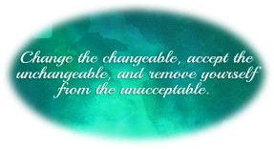
Understanding your level of control
Ask yourself ‘What can I take responsibility for in this situation?’
It is easy to become fixated on events or people we have no control over. Resilient people set their sights on what they can control rather than on blaming others or trying to move the unmovable.

Check your thought patterns
In times of change, it is easy to be swayed by your fears, emotions or past experiences. Take time to assess your thought patterns and assess how rational they are. You can generate more positive thinking by reminding yourself about the transitions or challenges you successfully navigated in the past. Think about your life events and list ways you have been resilient.

Adopt a growth mindset
Having a growth mindset helps you embrace challenges, learn from criticism, persist in the face of setbacks and find lessons and inspirations from others.

Be in the Present
Whilst it is useful to look to the past to find your strengths, worries about what future can sometimes make you forget to observe what is happening around you right now. To bring yourself back to the present, pay attention to how your body and mind responds to stress. Set aside time everyday to do something which helps you relax. Be thankfully for the little things in life.

Be kind to yourself

Any loss in one’s life creates a void, be it a loss of a loved one, loss of a job or end of a relationship. Even positive transitions, like an end of a phase in life - for instance seeing our children moving out, can bring feelings of sadness. During these times, do not push away those feelings of grief or sadness. Acknowledge the loss and pay attention to what you have learned form the experience. Seek support and camaraderie among friends and family. Do not shy away from asking for professional mental health support if you feel you need it during the transition.

Building personal resilience helps us in all aspects of life, including our workplace. There are numerous studies, theories and tools available on building resilience and developing resilient teams.
One study proposes that there are seven fundamental and interconnected components that can help individuals and teams build the skills to be happier and more resilient:

Competence: this directly links to our understanding of our roles and our ability to work to the expected standards. The more we face and navigate through challenging situations, the more competent we feel in dealing with problems.
Confidence: is our belief in our own abilities and is rooted in our competence. We gain confidence by being able to demonstrate our competence.
Connection: developing positive working relationships help lead to strong values and prevent alternative destructive paths to attention and progression. When we feel connected, we are more likely to stay involved with people and events even if in difficult situations.
Character: having strong set of values and morals strengthen an individual’s character and self-esteem. They feel empowered to recognise that they have the ability to make ‘wise’ choices and determine right from wrong.
Contribution: knowing the value we add to a team, department and organisation serves as a source of purpose and motivation. It is therefore so important to recognise team efforts and celebrate the little wins.
Coping: colleagues with wide range of coping skills are able to handle challenges and problems more effectively. The good news is, we can all practice and learn coping strategies and support our team members who may not feel as resilient at times of change.
Control: and lastly, understanding and realising that we can control our decisions and actions help us bounce quickly from disappointments and setbacks.

Thank you so much for the encouraging feedbacks and comments regarding this week’s topic. It is great to know that you are enjoying these focus weeks and are able to take something from it!

CRGPA Corporate Team

