How to change your teams background

This is what your camera should look like inside your teams meeting. The background may appear to be different on your screen, but the layout should be the same.
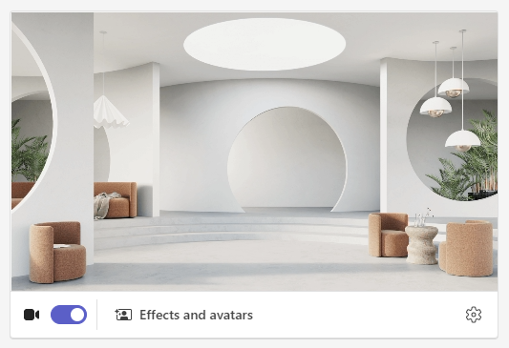
Click the “Effects and avatars” button located under your cameras output.

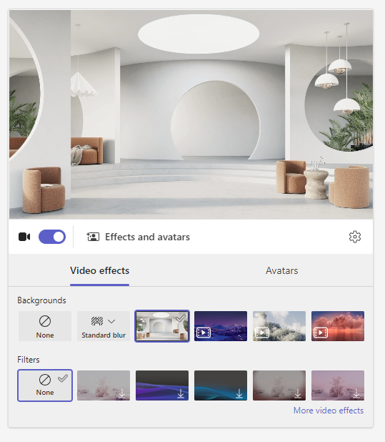
This layout will appear when pressed. Next click on “more video effects” for the option to upload a new image.

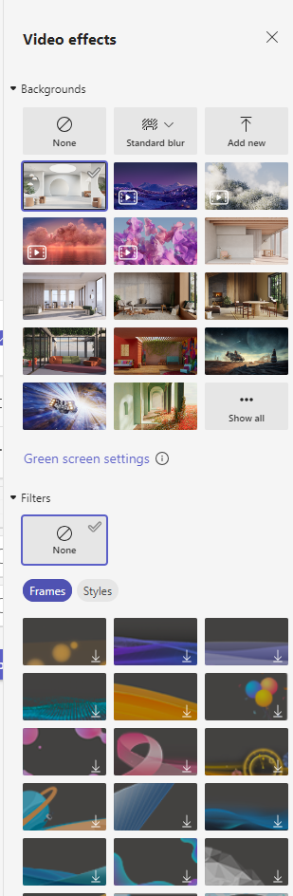
Once this menu appears on the right side of the screen, click “Add new” which should open file explore.

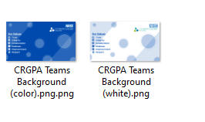
Select the image you would like to appear as your background.

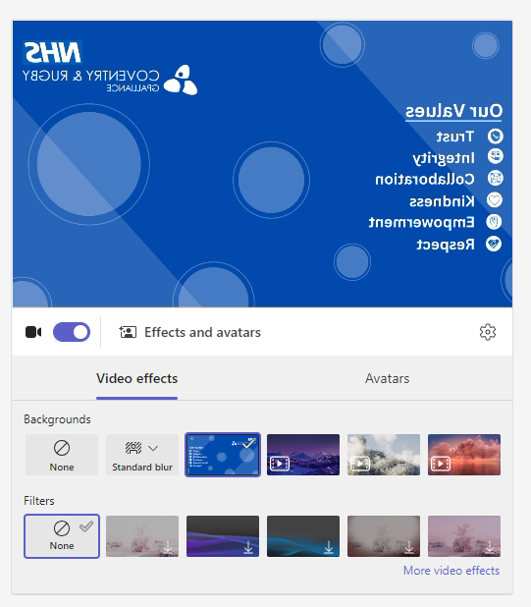
The image will appear to be back to front within the waiting room of the teams call. Once you are in the call, the image will appear normal on the participants screens.

