How to raise a PO in ApprovalMax.
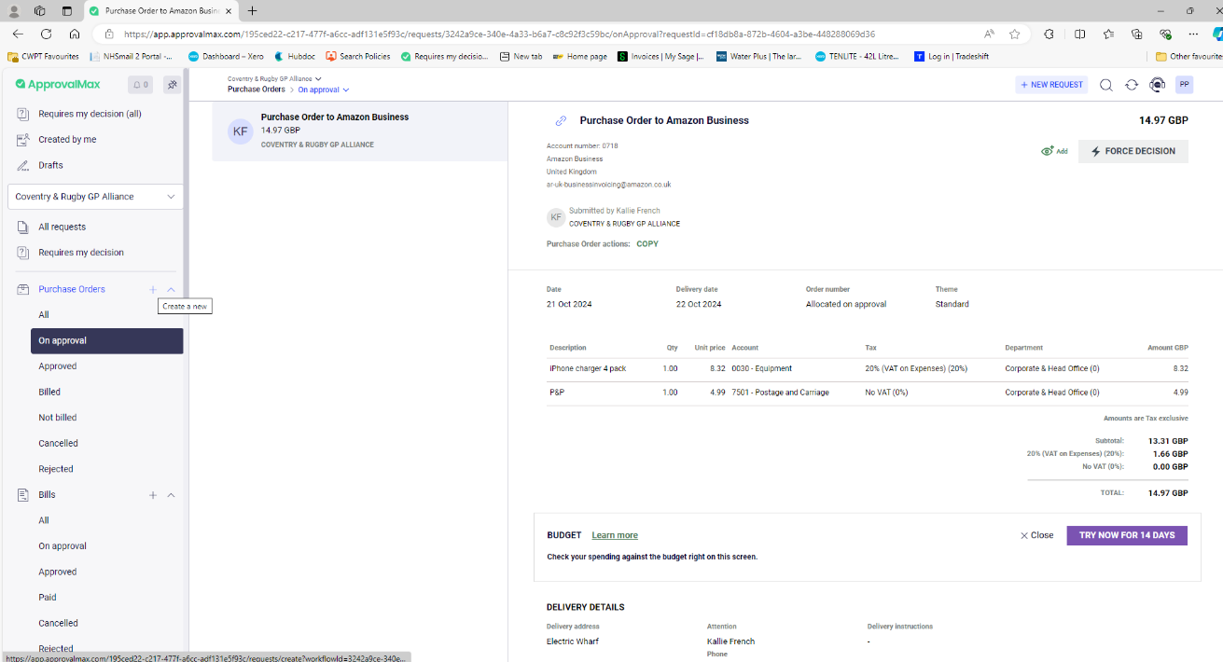
Click on the ‘+’ sign next to the ‘Purchase Orders’ tab on the left hand side.

Fill in the relevant details such as:
Contact: select the supplier.
Delivery Date: enter any date, can be tomorrow’s date.
Reference: enter the name of the requestor of the PO, if that is yourself then please put your name in there so if we need to chase who placed the order with the supplier we can quickly check and find out.

Description: what items are you ordering?
Qty: number of items needing to be ordered
Unit Price: the amount being charged for the item. This is without VAT.
Account: what type of item are you ordering? Stationary, medical consumables etc.
Tax Rate: if there is VAT, it’ll usually be 20% so please select ‘20% (VAT on expenses) (20%).
Department: where in the budget is the order coming from?
The tax is exclusive so the VAT will be added on to the ‘unit price’.
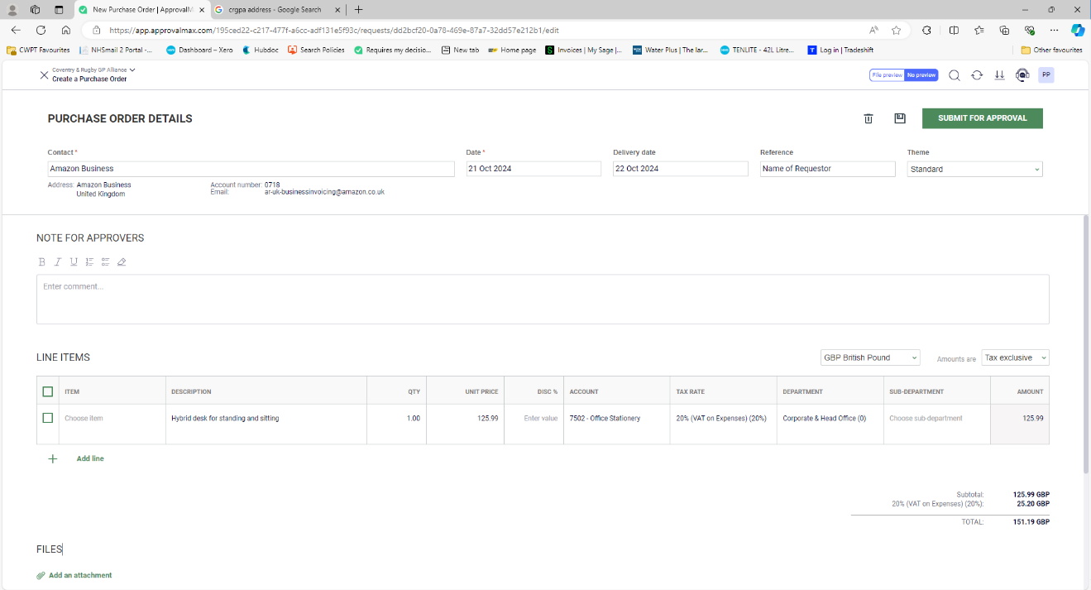

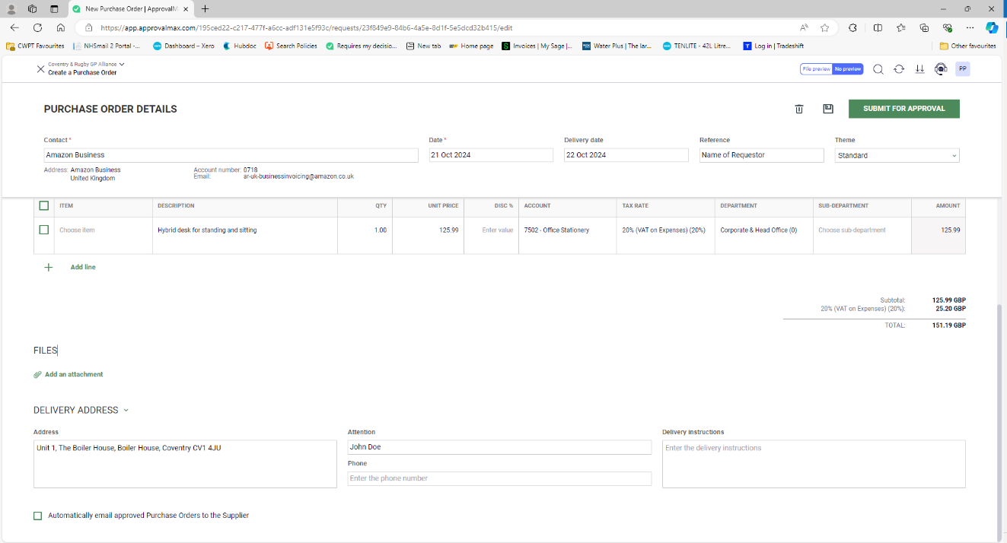
Fill in the ‘Delivery Address’ and ‘Attention’ and hit the ‘Submit for Approval’ button.

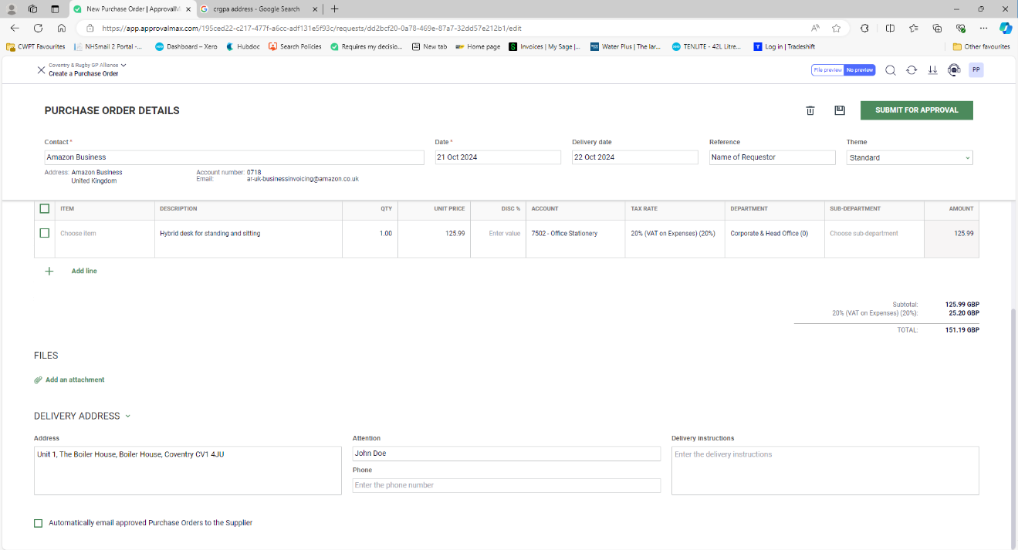
Your PO will then await approval from the relevant budget holder and you should receive a notification once a decision has been made.

