Welcome
Map- Directions to the Coventry and Rugby GP Alliance Office address
Unit 1 Ground Floor, The Boiler House, Electric Wharf, Sandy Lane, Coventry, CV1 4JU.
Phone: 024 77710980
We are here

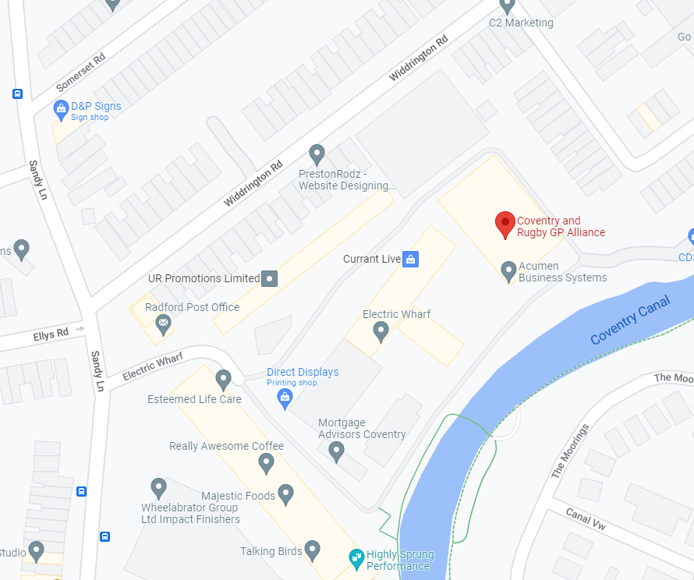
Instructions for visitors

1. Upon arrival, as you approach the entrance to the Electric Warf Site, please park in the visitor’s spaces which are located to the right of the electric gates.
2. Once parked, please proceed back to the pedestrian gate, which is located at the left side of the main electric gate.
3. Enter the following code: Key2580Key on to the keypad press the bell sign and wait for the gate to open. (It may already be open)
4. Once through the gates, please walk to the brick wall straight down the path, follow the road around to the right so you are facing the canal, then we are the unit immediately to your right. You will see the Alliance logo on the doors.

If there are no visitors’ spaces, please use street parking on Widdrington Road.
The Alliance is located at the red pin ‘The Boiler House’ (in front of the canal on the corner)
If you have a disability or any accessibility needs, please let the person you are visiting know and we can arrange alternative parking.

