

Document Title | APMS Practice Follow-Up Procedures for Telephone Consultations
Document Class | Standard Operating Procedure
Target Audience | All staff working within an APMS practice
Author & Designation | Angela Hargun, Practice Manager
Owner & Designation | Practice Managers
Version | 1.0
Approved By | Policy Review Group
Approved Date
Ratified By | Policy Review Group
Ratified Date
Review Date

Confidentiality Notice
This document and the information contained therein is the property of Coventry & Rugby GP Alliance (CRGPA). It must not be used by, or its contents reproduced or otherwise copied or disclosed without the prior consent in writing from CRGPA. All or part of this document may be released under the Freedom of Information Act 2000

Table of Contents

1.0 Introduction 3
2.0 Purpose 3
3.0 Roles and Responsibilities 3
4.0 Process and procedure 3
5.0 Implementation 5
6.0 Training and Support 5
7.0 Review 5
8.0 Monitoring and Compliance 5
9.0 Version Control 5
10.0 References 6
11.0 Appendices 7

1.0 Introduction
1.1 | This Standard Operating Procedure (SOP) outlines the follow-up procedures to be undertaken after did not attend (DNA) telephone consultations in a General Practice setting using the SystmOne or EMIS patient medical record clinical system. Telephone consultations are a core component of modern primary care, offering patients accessible and efficient clinical support. However, ensuring consistent and safe follow-up remains essential for high-quality patient care.
1.2 | This procedure applies to all clinical and administrative staff involved in patient care within a general practice. Following this SOP will help ensure timely follow-up, minimise the risk of errors or omissions, and support continuity of care.
1.3 | By embedding these procedures into routine practice, we aim to enhance patient safety, improve team and patient communication.

2.0 Purpose
2.1 | This SOP ensures that if a telephone consultation cannot be completed at the appointed time, the practice staff will promptly follow up with patients to reschedule and confirm the new time, ensuring continuity of care and maintaining patient satisfaction.

3.0 Roles and Responsibilities
3.1 | Reception/Administrative Staff:  - Make initial contact within 30 minutes of the missed appointment.  - Reschedule the consultation and confirm the new time with the patient.  - Document all actions taken within the patients’ medical records.
3.2 | Clinicians (GP/Nurse/Other):  - Review any notes on missed consultations and ensure that rescheduled appointments are noted in the patient’s records.
3.3 | Deputy/Practice Managers:  - Oversee the process, ensuring the protocol is followed and handling cases of repeated missed appointments.

4.0 Process and procedure
4.1 | Hodge Hill Process  Identifying Missed Telephone Consultations:  - The system will flag any missed or incomplete telephone consultations at the appointed time. The system either automatically flags the appointment as missed or this can be manually marked as DNA by selecting “D” on your keyboard in EMIS and right clicking on the patients name going to “Administration” and selecting “Did Not Attend” in SystmOne the appointment slot will then turn green.  - The clinician or administrative staff will note whether the consultation was missed due to technical issues, patient unavailability, or other reasons, this will then be sent to task box reception to rebook the patient in.  Immediate Action by Staff:  - Within 30 minutes of a missed consultation, the receptionist or administrative staff will attempt to reach the patient to:  - Apologise for the missed consultation.  - Confirm the reason for the missed appointment (if unclear).  - Offer to reschedule the consultation promptly.  Rescheduling Procedure:  - If the patient is available:  - Reschedule the consultation within the same day or as close to the original appointment time as possible.  - Confirm the new time with the patient and ensure it is suitable.  - If the patient is unavailable:  - Offer the next available slot or suggest an alternative time within 48 hours.  - Record the new appointment in the system and confirm with the patient.  Confirmation of Rescheduled Appointment:  - After rescheduling, a confirmation text or email will be sent to the patient with the new consultation time.  - A reminder message will be sent 24 hours before the new appointment.  Documentation:  - Ensure that all interactions, rescheduling details, and patient preferences are documented in the patient’s record for future reference.  - Note the reason for the missed consultation and any action taken to reschedule.  Escalation for Repeated Missed Consultations:  - If a patient repeatedly misses scheduled consultations or does not respond to follow-up attempts, escalate the case to the Deputy Practice Manager/Practice Manager or GP to decide whether further action, such as a face-to-face appointment or a review of care needs, is necessary.
4.2 | Alliance Teaching Practice Process  Clinical Staff - Telephone consultation  When a patient does not answer their telephone after an arranged telephone appointment the clinician will always attempt to call the patient two times. If two attempts have been made and failed the patient will be cancelled from the clinic and asked to rebook for another day via voice mail.  For vulnerable and known safeguarding patients, the clinicians will keep the call active on EMIS and try throughout the day. If at the end of the no contact has been made the clinicians will send a task to reception to request, they follow up and rebook patient.  Clinical Staff - Face to Face Consultation  When a patient does not attend their appointment at the arranged time, the clinician will send a message to the patient advising to re-book if needed.  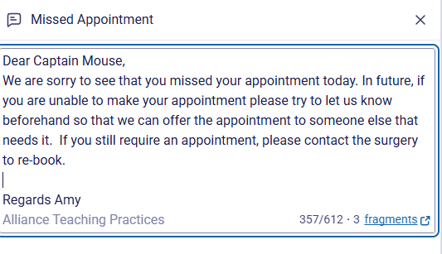  Reception Staff  Will attempt to contact vulnerable and known safeguarding as requested by the clinician, if no contact is made, they will send a letter.  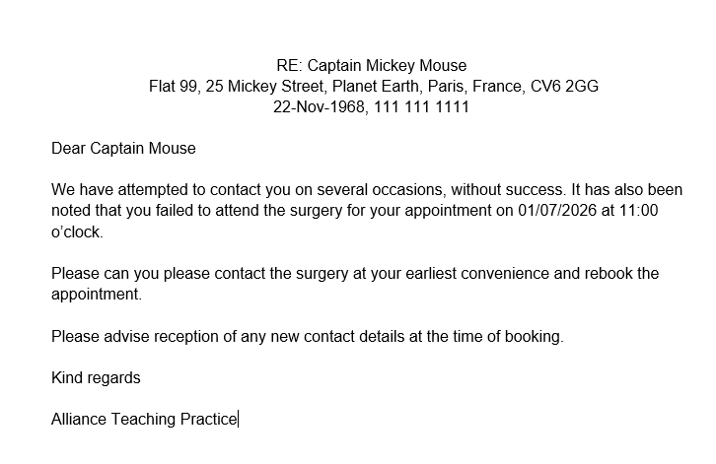  Operational Managers & Leads:  - Oversee the process, ensuring the protocol is followed and handling cases of repeated missed appointments.

5.0 Implementation
5.1 | An electronic copy of this SOP will be available to staff via the CRGPA Practice Index.
5.2 | This SOP will be implemented through application of the procedure in in practice.

6.0 Training and Support
6.1 | All employees will be offered relevant training commensurate with their duties and responsibilities. Employees requiring further support should speak to their line manager in the first instance.

7.0 Review
7.1 | This SOP will be reviewed every year by the SOP owner and/or SOP author and in accordance with the following on an as and when required basis:  - Legislatives changes  - Good practice guidelines  - Case Law  - Significant incidents reported  - New vulnerabilities identified  - Changes to organisational infrastructure  - Changes in practice

8.0 Monitoring and Compliance
8.1 | Monitoring and review of legislative changes and national/local developments which may impact on the content of this SOP will be the responsibility of the SOP owner and/or SOP author.  Where any changes are required the SOP owner and/or SOP author will be required to amend the SOP and arrange its distribution to all relevant parties and for the updated master version to be made available to all staff via the CRGPA Practice Index.  Compliance of this SOP should be undertaken as part of the SOP review.

9.0 Version Control

Version |  | Date | Author  (name and Designation) | Status | Comments
V1.0 |  | July 2025  July 2026 | Angela Hargun, Hodge Hill Practice Manager  Rachel Williams, Deputy Practice Manager  Sarah Forsyth, Chief Nurse  Amy Underwood & Jackie Mangozho, ATP Site Leads | Created  Reviewed and updated  Reviewed and updated  Reviewed and updated
 | 10.0 References

