

Document Title | Incident and Accident Reporting Policy
Document Class | Policy
Target Audience | All staff employed by or contracted by Coventry & Rugby GP Alliance
Author & Designation | Sarah Barnes, Head of Safety and Quality
Owner & Designation | Chief Nurse
Version | V1.3
CQC Domain | Safe, Effective, Well Led
Approved By | Policy Review Group
Approved Date
Ratified By | Safety and Quality Committee
Ratified Date
Review Date

Confidentiality Notice
This document and the information contained therein is the property of Coventry & Rugby GP Alliance (CRGPA). It must not be used by, or its contents reproduced or otherwise copied or disclosed without the prior consent in writing from CRGPA. All or part of this document may be released under the Freedom of Information Act 2000

Table of Contents

1. Introduction 4
2. Purpose 4
3. Scope 4
4. Definitions 4
5. Roles and Responsibilities 4
5.1 CRGPA Board 4
5.2 Chief Executive 4
5.3 Managers/Heads of Service 4
5.4 All CRGPA staff (including Bank/Contracted/Temporary Staff) 4
6. Process 5
7. Consultation 5
8. Implementation 5
9. Training and Support 5
10. Review 5
11. Monitoring and Compliance 6
12. Version Control 6
13. Equality Impact Assessment 6
14. References 7

1.0 Introduction
1.1 | Coventry and Rugby GP Alliance (CRGPA) acknowledge that the provision of its services is, by their very nature, makes it susceptible to risk from a variety of sources and is committed to providing effective high quality patient care and a safe and secure environment for all patients, staff and visitors.  This policy will help ensure that all incident reporting procedures are clear to staff working as part of the organisation, so that incidents are always reported, investigated and learned from, in order to mitigate or remove any risks moving forwards.
1.2 | This policy covers all clinical and non-clinical incident reporting, regardless of grade, including data/information losses and breaches.
1.3 | CRGPA recognises that it is essential that it has an open and learning culture for the safety of patients and staff to be maximised. This will ensure staff feel motivated and supported to report incidents and that staff and service users affected by incidents receive appropriate feedback and support about what has happened and the learning from this.

2.0 Purpose
2.1 | The purpose of this policy is to ensure that all incidents, accidents, near misses, and patient-safety events are reported, recorded, managed, and reviewed consistently and transparently. This enables organisational learning, improves patient and staff safety, and meets statutory and regulatory obligations, including the NHS Patient Safety Incident Response Framework (PSIRF), RIDDOR requirements, CQC regulations, and local Integrated Care Board (ICB) reporting arrangements.

3.0 Scope
3.1 | This policy applies to those members of staff that are directly employed by Coventry & Rugby GP Alliance and for whom Coventry & Rugby GP Alliance has legal responsibility. For those staff covered by a letter of authority / honorary contract or work experience this policy is also applicable whilst undertaking duties on behalf of Coventry & Rugby GP Alliance or working on Coventry & Rugby GP Alliance premises and forms part of their arrangements with Coventry & Rugby GP Alliance.

Definitions
4.1 | Incident  Any unplanned event that results in, or had the potential to result in, harm, loss or damage to a patient, staff member, visitor, or the organisation/property.
4.2 | Accident  An incident that results in injury, illness, or material damage.
4.3 | RIDDOR Reportable Accident  A workplace incident that meets reporting criteria under the RIDDOR – Reporting of Injuries, Diseases and Dangerous Occurrences Regulations - HSE.
4.4 | Patient Safety Incident  Any unintended or unexpected event that could have or did result in harm to one or more patients (PSIRF definition).  Reporting, investigating, and learning from them as per the NHS England » Patient Safety Incident Response Framework supports healthcare organisations to learn from mistakes, take action to keep patients safe and encourage system wide shared learning.
4.5 | Serious Patient Safety Incident (SPSI)  Under PSIRF, “serious incident” is no longer a fixed category. Instead, incidents requiring a Patient Safety Incident Investigation (PSII) are determined based on:  - Level of harm  - System learning potential  - Equity considerations  - Risk of recurrence  - Complexity
4.6
4.7 | Investigation  An investigation is an enquiry into circumstances surrounding an allegation, or incident which seeks to establish the facts and circumstances (what happened) and identify any contributing factors (how the incident happened) and underlying/root causes (why it happened). The key is to identify learning/actions to prevent recurrence and wider issues for learning. This does not seek to attribute blame.
4.8 | Near Miss  An event that could have caused harm but did not, either by chance or timely intervention. Near Misses are to be reported and managed as an incident.
4.9 | Harm  Harm is defined as injury (physical and psychological), disease, suffering, disability, or death. In most instances, harm can be considered to be unexpected, if it is not related to the nature of a person’s illness or underlying condition.  Actual harm must also be graded in line with definitions set out by the National Patient Safety Agency (NPSA) and in incidents where there is moderate or severe actual harm or a death, Duty of Candour must be considered.
4.10 | Loss or Damage  Loss or damage includes loss or damage to personal or CRGPA property, damage to CRGPA reputation or an inability to deliver services.
4.11 | Grading Incidents  All incidents recorded on Datix must be graded low, medium, high or serious using the CRGPA matrix (Appendix 1) by the person investigating the incident. The grade determines the action to be taken, which should be proportionate to the severity of the incident.  All incidents must be graded via Datix prior to final sign off.  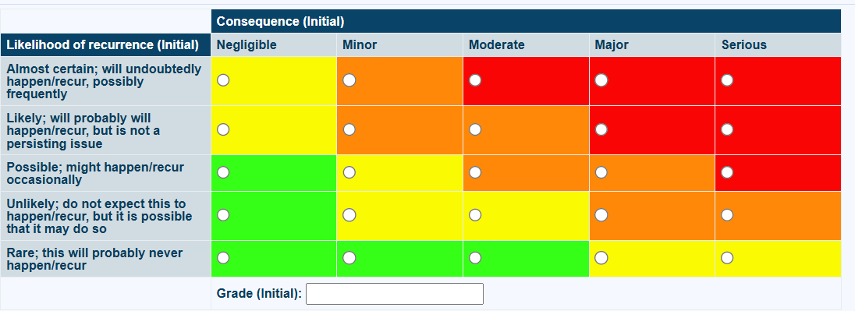
4.12 | Never Event  A list of serious, largely preventable patient safety incidents that should not occur if the available preventative measures have been implemented issued by NHS England.  Never Events should be reported as per the Incident Reporting Policy and escalated to the commissioners within two working days of identification. Never Events must also be reported to NHS England » Learn from patient safety events (LFPSE) service. The incident should be clearly labelled as a Never Event even where there is uncertainty at the time of reporting, as following agreement of commissioning organisation, incident reports can be retrospectively amended to downgrade from a Never Event with a clear audit trail that provides an explanation for the rationale for the change and who authorised is recorded.  The response to a Never Event should be coordinated by the Medical Director as soon as a Never Event is identified. This includes: Leading on final confirmation of Never Event status; organising the investigation; discussion with external parties, including patients/representatives and commissioners; identifying underlying contributory factors; and implementation of required actions and learning.
4.13 | Datix  Datix is the name of the incident reporting system used at CRGPA and it is expected that incidents, complaints, and compliments will be reported and recorded through Datix.  Staff can access Datix through the Datix icon on their desktop or via the CRGPA Staffzone page which includes a link to the reporting page of Datix.
4.14 | Personal data  Personal data is defined in the UK GDPR as:  ‘Personal data’ means any information relating to an identified or identifiable natural person (‘data subject’); an identifiable natural person is one who can be identified, directly or indirectly, in particular by reference to an identifier such as a name, an identification number, location data, an online identifier or to one or more factors specific to the physical, physiological, genetic, mental, economic, cultural or social identity of that natural person.
4.15 | Sensitive Data  Sensitive data is confidential information that, if exposed, could cause significant harm, discrimination, or financial loss to individuals or organisations, requiring strict protection and access controls, and includes things like health records, financial details, biometrics, government IDs, trade secrets, and political/religious beliefs.

5.0 Roles and Responsibilities

5.1 CRGPA Board
CRGPA Board has overall accountability for the quality and standards of care delivered by CRGPA including compliance with this policy.
CRGPA Board will ensure that appropriate structures are in place to implement effective incident reporting, management, review and learning.
The Board will be responsible for committing resources necessary to facilitate this.
The Board has oversight of overall themes and lessons learnt through regular Safety and Quality Committee reports to provide appropriate assurance.

5.2 Chief Executive Officer

The CEO is responsible for:
- Ensuring systems are in place to prevent, identify, report, and respond to incidents, accidents, near misses, hazards, and unsafe conditions
- Lead and model a just, open, and learning culture making it clear that learning, not blame, is the purpose of incident response
- Ensuring staff are supported and treated fairly
- Promoting psychological safety so staff feel able to speak up
- Challenging behaviours or systems that undermine PSIRF principles

5.3 Managers/Heads of Service
Managers/Heads of Service are responsible for:
- Ensuring staff understand and follow the reporting procedures
- Inform the Chief Nurse Immediately of any incidents/accidents that may be RIDDOR or CQC reportable
- Investigating incidents/accidents that have occurred in line with policy
- Sharing findings and learning from incidents/accidents with wider teams and ensuring findings feed into governance, training, and quality improvement

Ensuring learning from incidents is embedded in clinical practice
- Champion a just, fair, and compassionate culture, ensuring staff are treated fairly following incidents and are supported psychologically and professionally
- Making sure patients and families are treated with compassion and openness and are involved in learning responses where appropriate
- Ensuring Duty of Candour is upheld

5.4 All CRGPA staff (including Bank/Contracted/Temporary Staff)

All staff are responsible for:

Immediately reporting all incidents, accidents, near misses, hazards, and unsafe conditions to their Line Manger and via Datix
- Inform the Chief Nurse Immediately of any incidents/accidents that may be RIDDOR or CQC reportable

Complete incident forms accurately and promptly ensuring accounts are detailed and actions taken are clear

Escalating urgent safety concerns immediately to their Line Manager, Team Lead, Practice Manager or person on call
- Cooperating with learning responses, reviews, or investigation and participating in reflective discussions in a just and respectful manner
- Contributing to a just culture, focused on learning rather than blame
- Treating colleagues fairly and with respect following incidents
- Speaking up about safety concerns without fear of reprisal
- Challenging unsafe practices appropriately
- Treating patients and families with compassion and respect
- Listening to and escalate patient or family concerns
- Supporting involvement of patients and families in learning responses where appropriate
- Taking immediate action to make the situation safe following an incident or accident
- Summoning appropriate first aid or emergency assistance

5.5 Chief Nurse

The Chief Nurse is responsible for
- Overseeing incident recording, investigations, coding, closure, submissions to LFPSE
- Ensuring RIDDOR reporting (when applicable)
- Liaising with the ICB/CQC where an incident meets criteria for external oversight/awareness
- Assigning investigators to incidents
- Coordinating investigations or learning responses in line with PSIRF principles
- Providing assurance and reports on statistics and themes around incidents to the Safety and Quality Committee
- Making sure patients and families are treated with compassion and openness and are involved in learning responses where appropriate
- Ensuring Duty of Candour is upheld
- Challenging behaviours or systems that undermine PSIRF principles
- Acting as the Accountable Officer for serious patient safety concerns
- Chairing the weekly incidents and complaints meetings
- Ensuring all incident records have been fully completed and investigated before final closure

5.6 Medical Director(s)

The Medical Director/Associate Medical Director(s) is responsible for:

Providing clinical oversight and investigation where required

Ensures learning from incidents is embedded in clinical practice
- Providing feedback/support to clinicians

Supporting open disclosure and Duty of Candour requirements

5.7 Health and Safety Representatives

The Organisation’s Health and Safety Representatives are responsible for:
- Ensuring compliance with statutory H&S requirements
- Leading and supporting on investigation of workplace injuries
- Ensuring any workplace accidents are reported in the sites accident book as well as on Datix
- Maintaining accident book and risk assessment records
- Reporting to the Health and Safety Forum on all health and safety related incidents, accidents, near misses, hazards, and unsafe conditions
- Inform the Chief Nurse Immediately of any incidents/accidents that may be RIDDOR or CQC reportable

5.8 Governance Team

The Governance Team are responsible for:
- Supporting the administration surrounding incidents by monitoring the safety inbox, sending acknowledgments to incidents received directly into the safety inbox and general administration of Datix e.g. adding new users, uploading emails sent to the safety inbox to Datix
- Reporting information governance breaches to the organisation’s IG team (Arden & Gem) for record keeping purposes, act upon advice on next steps/actions required
- Reporting any information governance breaches to the ICO within the required deadline if required

6.0 Process
6.1 | Incident Reporting Process  The reporting of incidents has two key purposes:  - To provide a formal record that an incident has occurred.  - To trigger an investigation to prevent reoccurrence and to ensure organisation wide learning, thus embedding a fair and just culture across CRGPA.  Immediate Actions:  - Ensure safety of patient, staff, and/or others  - Seek medical assistance if required  - Isolate equipment or environment if relevant  - Inform the Line Manager, Team Lead, Site Lead, senior person in charge, Health and Safety Representative as appropriate
6.2 | Recording the Incident  All incidents, accidents and near misses must be recorded on the Practice Incident Reporting System Datix: Coventry and Rugby GP Alliance Incident Report Form within 24 hours. Only facts, not opinions, should be documented.  In the event of an IT outage/issue with accessing the Datix system use the incident reporting form in Appendix 1. Verbally inform the leads who need to be informed of the accident/incident and email the completed form to crgpa.safety@nhs.net when able, for the Governance Team to retrospectively enter onto Datix.  Stating the facts of an event on an Incident Report does not constitute an admission of liability of any kind on any person and staff reporting or involved in an incident should not be treated unfairly because of this. Nevertheless, completed forms may be requested for legal proceedings and so must be completed legibly, comprehensively and carefully.  Any member of staff may report an incident, and this is usually the person who is aware of all the available facts (e.g. victim, witness,). If a person is too traumatised to complete the form, then someone else should complete on their behalf.  Any incidents reported via Datix must not contain any personally identifiable information. Datix will provide guidance as to where identifiable information can be entered.  Fields include:  - Your name  - Surname  - Job Role  - Phone Number  - Email  - Your Manager  - Incident Date  - Incident Time  - Site  - Service  - Location  - Describe What Happened - Please give as much detail as possible about what the incident Do not include any personal identifiable information in this text field.  - What immediate actions did you take? - What immediate actions did you take? - Please give as much detail about what you did following the incident eg what actions you took, who you told etc. Do not include any personal identifiable information in this text field.  - Incident effecting  - Category  - Subcategory  - Was any other person involved in the incident?  - Any documents to be attached? (this is where personally identifiable information can be included)  There may be instances where an incident does not come to light for a period of time after the event, in which case it should be reported as soon as it is discovered. If an incident is reported by phone, due to its serious and urgent nature, then an incident report is still required and must be completed and submitted as described above.  The Chief Nurse will ensure that an appropriate investigator has been assigned to the incident within 3 working days.  In the event of a Datix/internet outage the manual incident reporting form must be used in Appendix 1. This is to be submitted to crgpa.safety@nhs.net as soon as able. The incident must also be reported verbally to the Line Manager for awareness and support with actions required. Printed copies of these forms must be available for manual completion if required in the event of a major internet outage.  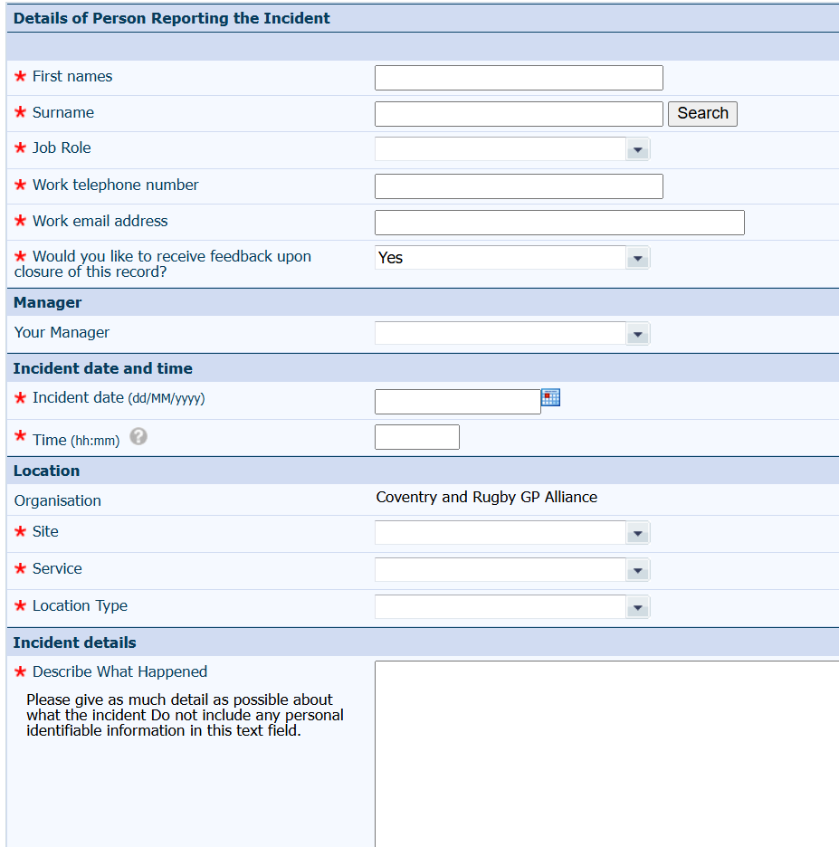  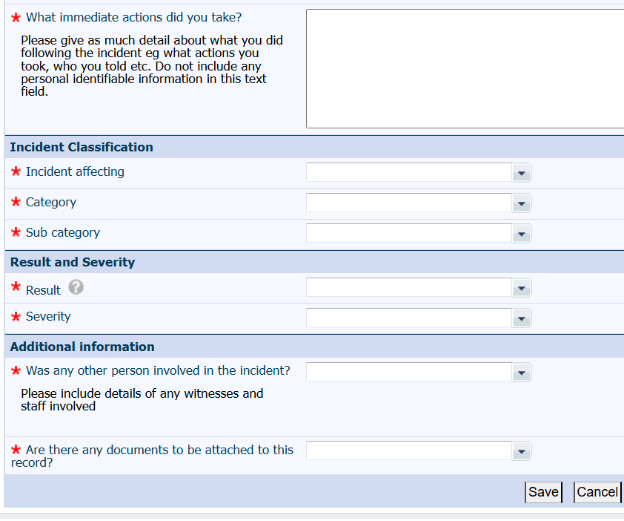
6.3 | Anonymous reporting/raising concerns  It is recognised that some staff may wish to provide a report in strict confidence and in such cases staff may do so by contacting their Line Manager, Chief Nurse, Medical Director or Human Resources. In such cases, staff may wish to familiarise themselves with the CRGPA Freedom to Speak Up and Whistleblowing Policies.  A Datix record will need to be completed by the staff member who has received the report, they must take care to ensure the record remains confidential and no personal information is disclosed.
6.4 | Incidents involving drugs  Incidents of drug errors, e.g. omissions, errors in recording, wrong dosage (amount and interval), wrong administration, dispensing error etc. should be reported as an incident as detailed within this policy in addition to the reporting of the incident to the Chief Nurse and/or Medical Director. The grading applied to the incident will determine how the incident will then be managed.
6.5 | Adverse drug reactions  Adverse drug reactions should be reported in line with the recommendations from the Committee of Safety of Medicines (CSM) using the Yellow Card | Making medicines and medical devices safer reporting site (see current Adverse reactions to drugs | Medicines guidance | BNF | NICE)  Such incidents should also be reported as detailed within this policy document.  If an incident involves medication, the medication should be quarantined, clearly labelled and stored safely, with details recorded on the Incident Report, in case this is required as evidence in the investigation.
6.6 | Incidents Involving Equipment  Any equipment involved in an incident should be withdrawn from use by the line manager / person in charge and must be retained, labelled and kept in a safe place for examination.  The exact location of the incident must be identified, and the asset number of the equipment must be included on the incident report.
6.7 | Physical and Non-physical Assaults  All assaults on staff / patients, including those which are the result of a clinical cause i.e. dementia or confusion due to the individual’s medical problem, must be reported as an incident.
6.8 | Security Incidents  Security related incidents resulting in loss or damage to property (whether this belongs to staff, patients or the organisation), insufficient locking of buildings/equipment whether accidental or non-accidental, must be reported as an incident.
6.9 | Removal of Patients Following Prior Warning of Zero Tolerance  In line with NHS England guidance, the practice will consider removal of a patient from the list where there have been at least one prior warning issued within the preceding 12 months and further concerns arise. For non-violent incidents, a patient would be expected to have received a clear written warning about their behaviour before removal is pursued. Where two zero-tolerance warning letters have been issued within a 12-month period, this may lead to removal from the practice.  The organisation must be satisfied that there are reasonable grounds for doing so, including evidence of ongoing inappropriate behaviour or an irretrievable breakdown in the doctor–patient relationship. Removal may be appropriate where behaviour has persisted, reoccurred, or escalated despite previous warnings, and where the patient has been given sufficient opportunity to modify their conduct.  In assessing whether removal is justified, the practice will consider whether any further incident has occurred following the issue of warning letters. A subsequent incident will generally support a decision to remove.  Except in cases involving violence or a serious threat of violence where the police are involved, removal will normally be undertaken via the standard 8-day removal process in accordance with NHS England and Primary Care Support England (PCSE) procedures. Immediate removal will only be used where there is a clear risk to the safety of staff or others.  Prior to making a final decision, the organisation will consider whether the patient’s behaviour may be influenced by factors such as mental health conditions, learning disability, or cognitive impairment, and whether reasonable adjustments have been made where appropriate. The practice will also ensure that any decision to remove is made fairly, does not constitute discrimination, and is not taken solely in response to a patient making a complaint.
6.10 | Safeguarding Incidents  CRGPA recognises that some patients are more likely to be vulnerable than other population groups and that ensuring safeguarding processes are effective is essential. Staff should also refer to CRGPA Safeguarding Children and Adults Policies.  The national framework requires that all incidents involving allegations of abuse are investigated. This may include where there has been a failure to take a complete history, gather information from which to base care plan/treatment, assess mental capacity and/or seek consent to treatment, or fail to share information when to do so would be in the best interest of the client in an effort to prevent further abuse by a third party and/or to follow policy on safer recruitment.  Any incident where a patient makes an allegation of abuse, whether by someone outside CRGPA (i.e. carer), another service user or a member of staff must be reported as an incident. Managers reviewing Incident Reports must be alerted to safeguarding issues.  If an Incident Report raises a safeguarding issue the manager must decide if there is a safeguarding concern. If there is such a concern, a safeguarding alert must be raised with the Chief Nurse or Medical Director promptly so that this issue can be investigated.  A safeguarding concern can come to light at any point of an investigation process and must be dealt with in line with this section and related policies whenever it is identified.
6.11 | Patient Safety Incident Response Framework (PSIRF)  The Patient Safety Incident Response Framework (PSIRF), published by NHS England (NHSE) In March 2020, replaces the Serious Incident Framework (SIF) and no longer makes distinction between ‘patient safety incidents’ and ‘serious incidents’.  PSIRF promotes a proportionate approach to responding to patient safety incidents by ensuring resources allocated to learning are balanced with those needed to deliver improvement.  The four key aims of the Patient Safety Incident Response Framework (PSIRF) are:  - Compassionate engagement and involvement of patients, families, carers and staff affected by patient safety incidents — ensuring they are treated with empathy, included in discussions, and supported throughout the response process.  - Application of a range of system-based approaches to learning from patient safety incidents — using methods that explore underlying system factors and interactions, not just single causes.  - Considered and proportionate responses to patient safety incidents — tailoring how incidents are reviewed and investigated based on context and learning potential rather than rigid thresholds.  - Supportive oversight focused on strengthening response system functioning and improvement — governance that helps organisations learn, improve and integrate responses into wider safety systems rather than assigning blame.  These aims shift incident response toward learning, system improvement and compassionate involvement.  PSIRF Pilot Programme in General Practice  In June 2024, NHS England commenced a pilot programme to explore how the Patient Safety Incident Response Framework (PSIRF) can be applied within general practice. The pilot involves GP practices, Primary Care Networks, and Integrated Care Systems and is testing how PSIRF principles—such as proportionate incident responses, learning-focused reviews, compassionate engagement, and a just culture—can be implemented in the context of primary care.  Learning from the pilot is being gathered to inform future national guidance, with outputs and recommendations expected to be shared from March 2026. While general practice is not currently required to formally adopt PSIRF, Coventry and Rugby GP Alliance is committed to aligning with emerging learning from the pilot and to progressively implementing PSIRF principles in a way that is proportionate, sustainable, and appropriate to general practice. Our approach will continue to evolve as national expectations and guidance develop.
6.12 | Learn From Patient Safety Events (LFPSE)  Under the current requirements for GP practices in England, general practices are expected to participate in the Learn From Patient Safety Events (LFPSE) service as part of national patient safety reporting and improvement activity.  All healthcare staff in England, including those working in primary care, are encouraged to use LFPSE to record any events where a patient was harmed, or could have been harmed, there has been a poor outcome, but it is not yet clear whether an incident contributed or not, risks to patient safety in the future have been identified and where good care has been delivered that could be learned from to improve patient safety.  This replaces the older National Reporting and Learning System (NRLS), which was decommissioned in June 2024 NHS England » Learn from patient safety events (LFPSE) service.  Include near-misses and no-harm events: Although local practice policies may differ, guidance emphasises that reporting should capture a broad range of safety events — not just those resulting in harm — to support improvement.
6.13 | Accidents  All accidents, including near misses must be reported and recorded in the site’s accident book. It is important that all staff know the correct procedure for reporting an accident. The person receiving a report should also have adequate training/experience to know what is expected of them and the actions to take.  The report should be completed either by the injured person (for minor injuries), the first aider or the person reporting the accident, should an injury render an employee unable to report it themselves. Details of near-miss incidents should be reported separately via Datix.  All accidents and near misses will be investigated and the outcome recorded.  When an accident occurs:  - Ensure the area is safe and remove immediate hazards.  - Provide first aid (if trained) and/or call 999 if required.  - Notify the Practice/Site Manager or senior staff member as soon as possible.  - Record the accident in the Accident Book on the same day.  - Complete a Datix report for all accidents, incidents and near misses.  - Inform the patient or visitor of the reporting process where appropriate.  The person leading the investigation should have the necessary experience and/or have been appropriately trained in conducting investigations and have a sound knowledge of health and safety matters.  An investigation will help to determine:  - What went wrong  - Why it went wrong  - The risk of a similar incident happening again and how this may be reduced  - Relevant information for further investigations, either legally or for insurance purposes  Accident books must be kept in a safe but accessible place in which all staff are aware of the location. The organisation’s accident books are kept in the locations below at each site:  Electric Wharf Office: In the kitchen, on top of the fridge  Hodge Hill: In reception  ATP Stoke Aldermoor: Cupboard in the Reception area  ATP Foleshill: Manager’s Office  ATP City of Coventry Healthcare Centre: Desk drawer in Office area  ATP Broad Lane: In reception back room  Once an accident form has been completed this must be removed from the accident book and kept in separate folder in a secure locked draw/cupboard, to maintain confidentiality.  Completed accident forms are generally kept for a minimum of three years, but there are important exceptions depending on who was involved and the type of incident.  Retention periods for accident forms  - Adults – keep records for at least 3 years from the date of the accident, though many NHS organisations retain for up to 7 years for governance and legal protection.  - Children or young people – keep until the person reaches 25 years of age (because claims can be made up to age 21).  - RIDDOR‑reportable incidents – keep for at least 3 years, though many NHS organisations retain for up to 7 years for governance and legal protection.  - Staff accidents – keep for at least 3 years, but many practices align with HR/occupational health retention (often 6 years).
6.14 | RIDDOR  The HSE has produced guidance on the Reporting of Injuries, Diseases and Dangerous Occurrences Regulations (RIDDOR) which focuses on the following areas:  - Reportable incidents  - Who should report  - Making a RIDDOR report  - Specified, reportable injuries  - Dangerous occurrences  - Reportable occupational diseases  - Carcinogens and biological agents  Reportable incidents  The organisation is responsible for ensuring that RIDDOR-related accidents are reported and will only report accidents if they happen when:  - The accident is work-related, and  - It results in an injury of a type that is reportable  The HSE provides detailed information regarding the types of reportable incident/accident, including but not limited to:  - The death of any person  - Specified, reportable injuries to workers including:  - Fractures (other than to fingers, thumbs and toes)  - Amputations  - Any injury likely to cause permanent blinding or reduction in sight in one or both eyes  - Any crush injury to the head or torso causing damage to the brain or internal organs in the chest or abdomen  - Serious burns (including scalding) which cover more than 10% of the body or cause significant damage to the eyes, respiratory system or other vital organs  - Any scalping requiring hospital treatment  - Any loss of consciousness caused by a head injury of asphyxia  - Any other injury arising from working in an enclosed space that leads to hypothermia or requires resuscitation or hospital admittance for more than 24 hours  - Over seven-day incapacitation of a worker  - Over three-day incapacitation  - Non-fatal accidents to people other than workers  Occupational diseases  The HSE advises that this organisation must report diagnoses of certain occupational diseases where these are likely to have been caused or made worse by their work. This includes but is not limited to:  - Carpal tunnel syndrome  - Severe cramp of the hand or forearm, tendonitis or tenosynovitis  - Hand-arm vibration syndrome (HAVS)  - Occupational dermatitis  - Occupational asthma  - Any occupational cancer  - Any disease attributed to an occupational exposure to a biological agent  Additional information can be found in the HSE’s reportable occupational diseases guidance.  Carcinogens, mutagens and biological agents  The HSE explains that cases of cancer must be reported when there is an established causal link between the type of cancer diagnosed and the hazards to which the person has been exposed through work. Detailed information is available in the HSE’s reportable carcinogens guidance document.  Dangerous occurrences  The HSE defines a dangerous occurrence as one that arises out of, or in connection with, work and could risk harm to others. Note, not all events need to be reported. This organisation will follow the HSE guidance on dangerous occurrences, which are to be reported under Schedule 2 of RIDDOR.  Gas incidents  Distributors, fillers, importers and suppliers of flammable gas must report incidents in connection with that gas, where someone has:  - Died  - Lost consciousness, or  - Been taken to hospital for treatment  Exemptions  There are a few exemptions to the requirement to report under RIDDOR. These are:  - When an accident occurs during medical treatment or any examination carried out or supervised by a Doctor or Dentist  - When it would duplicate similar reporting requirements – for example, under the Ionising Radiation (Medical Exposure) Regulations 2017  Reporting process  When reporting incidents under RIDDOR, the responsible person at this organisation (Chief Nurse) can use the following methods:  - Online (preferred method)  The organisation will complete the appropriate online report form. The form will then be submitted directly to the RIDDOR database, and a copy of the report will be submitted to the organisation.  - Telephone (Monday to Friday, 8.30 am to 5.00 pm)  Fatal accidents and accidents resulting in specified injuries to workers only, can be reported by telephone as well as online. Call the Incident Contact Centre (ICC) on 0345 300 9923.  - Out of hours (weekends, public holidays and between 5.00 pm and 8.30 am)  The HSE has a duty officer to whom serious or major incidents are to be reported out of hours by telephoning 0151 922 9235.  Examples of such incidents include:  - A work-related death  - A serious incident where there have been multiple casualties  - An incident that has caused major disruption such as the evacuation of people, closure of roads, large numbers of people attending hospital, etc.  - Flammable gas incidents  In the event of a reportable incident occurring that involves flammable gas supplied to the organisation, this is to be reported to the flammable gas supplier.  Note: Should an employee sustain a reportable injury while working away from the premises, then the organisation must ensure that this is reported under RIDDOR.  The HSE provides detailed guidance on how to report under RIDDOR.
6.15 | CQC Notifiable Incidents  Under the Care Quality Commission (CQC) Regulations 2009, Regulation 18: Notification of other incidents - Care Quality Commission sets out notifiable incidents that registered providers must report to the CQC.  Providers must notify CQC of all incidents that affect the health, safety and welfare of people who use services. The full list of incidents is in the text of the regulation.  NHS trusts and NHS Blood and Transplant can report some regulation 18 notifications via LFPSE – these are serious injuries, abuse and allegations of abuse, and events that stop a service running safely and properly. All other providers must send these notifications directly to CQC.  18(2) The incidents referred to are:  (a) any injury to a service user which, in the reasonable opinion of a health care professional, has resulted in—  (i) an impairment of the sensory, motor or intellectual functions of the service user which is not likely to be temporary,  (ii) changes to the structure of a service user's body,  (iii) the service user experiencing prolonged pain or prolonged psychological harm, or  (iv) the shortening of the life expectancy of the service user;  (b) any injury to a service user which, in the reasonable opinion of a health care professional, requires treatment by that, or another, health care professional in order to prevent—  (i) the death of the service user, or  (ii) an injury to the service user which, if left untreated, would lead to one or more of the outcomes mentioned in sub-paragraph (a);  Guidance on 18(2)  - Injuries include those that lead to, or that if untreated are likely to lead to, permanent damage – or damage that lasts or is likely to last more than 28 days – to:  - a person's sight, hearing, touch, smell or taste  - any major organ of the body (including the brain and skin)  - bones  - muscles, tendons, joints or vessels  - the development after admission of a pressure sore of grade 3 or above that develops after the person has started to use the service  - any injury or other event that causes a person pain lasting, or likely to last, for more than 28 days  - intellectual functions, such as  - intelligence  - speech  - thinking  - remembering  - making judgments  - solving problems.  - Injuries or events leading to psychological harm, including:  - post traumatic stress disorder  - other stress that requires clinical treatment or support  - psychosis  - clinical depression  - clinical anxiety  (These lists are not exhaustive)  Notification of deaths  The organisation does not need to notify CQC about every death of a registered patient.  The organisation must notify the CQC if the death occurred whilst care was being provided. For example:  - while a patient was in consultation with a healthcare professional  - while at your health centre, practice or surgery  - during a home visit  CQC must also be notified of deaths that occurred within two weeks of a clinical interaction with practice staff if the death:  - was, or may have been, as a result of the care or how it was provided, and  - could not be attributed to the course which the illness or medical condition would naturally have taken if the deceased had been receiving appropriate care and treatment.  For example, the CQC need not be notified if a cancer patient with a terminal diagnosis died the week after an appointment for pain relieving medication. This is because the patient the disease took its predictive course, and the appointment for pain relief did not contribute to their death in any way.
6.16 | Information Governance (IG) Incidents  An information incident can be any real or potential breach which may affect the confidentiality of information that is processed by CRGPA. CRGPA holds large amounts of confidential information about service users and staff. The format can be in hard copy (i.e. patient records, clinic lists), electronic (laptops, emails) or both.  An information incident can vary between:  - “Personal data” and “sensitive data” left unattended or displayed in an open plan office/practice  - Stolen/lost laptop containing personal data and/or sensitive data  - Unauthorised access into an area where confidential information is stored  - Passwords and login details written down and left unattended.  - “bcc” option is not utilised when sending emails to multiple recipients, using their personal email addresses about specific services.  - Unauthorised access to patient or staff records  (These lists are not exhaustive)  Staff are responsible for reporting IG breaches as soon as they are identified, following the incident reporting procedure, and providing accurate and timely details to support investigation. Early reporting enables appropriate containment, assessment of impact, compliance with legal and regulatory requirements, and implementation of corrective actions to prevent recurrence.  The Governance Team must ensure that all information governance breaches are reported to the organisation’s IG Team (Arden & Gem CSU) as soon as they become aware. The Governance Team will provide as much information as possible including the types of information that was breached. Arden & Gem will acknowledge receipt and provide regular reports to the Governance Team on how many IG incidents have been recorded in each quarter. They will also provide advise on next steps and what action should be taken.  The governance team are responsible for reporting IG breaches (when required) to the Information Commissioners Office (ICO).  Under the UK GDPR and Data Protection Act 2018, a data breach must be reported to the ICO if it is likely to result in a risk to the rights and freedoms of individuals.  A breach should be reported when it could cause harm to individuals, such as:  - Identity theft or fraud  - Financial loss  - Damage to reputation  - Loss of confidentiality of sensitive personal data  - Discrimination or social disadvantage  A breach does not need to be reported if it is unlikely to result in any risk to individuals, for example:  - Data is securely encrypted and cannot be accessed  - The breach is quickly contained with no data actually accessed  - Minimal personal data involved with no realistic risk of harm  The ICO has a self-assessment tool to help asses whether a breach is reportable Self-assessment for data breaches | ICO.
6.17 | Sharing of Lessons Learned / Good Practice from investigations  It is essential that information from incident investigations is shared with staff involved in or directly affected by the incident and any actions taken. Feedback will be provided by the Chief Nurse once an incident is closed. For complex incidents a face-to-face feedback session with one or more staff may be appropriate  Information pertaining to lessons learned / good practice post investigation will be shared within and across the organisation using a number of media and approaches, depending on content. These will primarily involve:-  - Communication to the relevant committees/groups as described in this policy.  - Communications with staff at all levels via:-  - Key Messages  - Team Meetings  - Team Time
6.18 | Incidents and Complaints meeting  The Chief Nurse will chair the incidents and complaints meeting held on a weekly basis to allow discussions around all open incidents and complaints, assign investigators to new incidents and agree actions.  An action tracker is used to keep up to date with agreed actions and deadlines which is sent out after each meeting.

7. Consultation
7.1 | CRGPA Staff will have the opportunity to comment on any drafts and/or amendments to this policy via CRPGA Staff Zone following presentation at Policy Review Group.

8. Implementation
8.1 | This Policy will be available to all persons working for CRGPA. An electronic copy will be available on CRGPA Policy Portal.
8.2 | This policy will be implemented through application of the policy in practice.

9. Training and Support
9.1 | All employees will be offered relevant training commensurate with their duties and responsibilities. Employees requiring support should speak to their line manager in the first instance. Support may also be obtained through Human Resources.

10. Review
10.1 | This policy will be reviewed every three years by the Policy lead and in accordance with the following on an as and when required basis:  - Legislatives changes  - Good practice guidelines  - Case Law  - Significant incidents reported  - New vulnerabilities identified  - Changes to organisational infrastructure  - Changes in practice

11. Monitoring and Compliance
11.1 | Monitoring and review of legislative changes and national/local developments which may impact on the content of this policy will be the responsibility of the Policy author and/or Policy Owner.  Where any changes are required the Policy Author and/or Owner will be required to amend the policy and arrange for its presentation at the next available Policy Review Group for review and ratification.  Compliance with this policy will be reviewed annually, on the anniversary of the policy ratification date.

12. Version Control
Version | Date | Author  (name and Designation) | Comments
1.0 | 6/12/19 | Sarah Barnes, Head of Safety and Quality | Created
1.1 | 30/12/20 | Kate Harris, Governance Facilitator | Amended section 4.1 CRGPA Board (pg. 6) to reflect their oversight and quality assurance
1.1 | 06/01/2021 | Sarah Barnes, Head of Safety and Quality | Confirmed amendment  and final version
1.2 | 09/01/2026 | Kallie French, Governance Manager | Renamed, transferred into current template, updated
1.3 | 01/07/2026  05/07/2026 | Hollie Chaplin, Governance Assistant  Sarah Forsyth, CNO/COO | Added in section for removal of patients  Reviewed

13. Equality Impact Assessment
13.1 | As part of its development, this procedural document and its impact on staff, patients and the public has been reviewed in line with Coventry & Rugby GP Alliance’s Equality Duties. The purpose of the assessment is to identify and if possible remove any disproportionate adverse impact on employees, patients and the public on the grounds of the protected characteristics under the Equality Act.

 |  | Yes/No |  | Comments
1. | Does the document affect one group more or less favourably than another based on:-
 | Race |  | No
 | Religion/Religious Belief |  | No
 | Gender |  | No
 | Gender Reassignment |  | No
 | Sexual Orientation |  | No
 | Age |  | No
 | Any Form of Disability, impairment or mental health problems |  | No
 | Marriage and civil partnership |  | No
 | Pregnancy/Maternity |  | No
2. | Is there any evidence that any groups are affected differently? |  | No
3. | If any potential discrimination has been identified, are there any valid, legal or justifiable reasons? |  | NA
4. | Could the document have a negative impact? |  | No
 | If so, can the impact be avoided/reduced? |  | NA
 | If not, what alternative is there to achieving the document without the negative impact? |  | NA
5. | Name and Designation of 3 staff members who have contributed to or considered this assessment |  |  |  | Kallie French  Sarah Forsyth  Hollie Chaplin
6. | Date of Assessment |  |  |  | 16/04/2026

13.2 | Any potential discriminatory impact which has been identified must be referred back to the author of the document for consideration of additional actions to reduce or remove the potential discriminatory impact.

References
NHS England » Patient Safety Incident Response Framework
Health and Safety at Work etc. Act 1974
The Reporting of Injuries, Diseases and Dangerous Occurrences Regulations 2013
NHS England » Learn from patient safety events (LFPSE) service
Data Protection Act 2018
The fundamental standards - Care Quality Commission
Self-assessment for data breaches | ICO
Adverse reactions to drugs | Medicines guidance | BNF | NICE
Yellow Card | Making medicines and medical devices safer
CRGPA Zero Tolerance Policy

Appendix 1

Reporting template for use in Datix outage
Please use this form to record an incident or near miss in the event of a Datix outage. This form must be completed and email to crgpa.safety@nhs.net as soon after the incident has occurred.

Please ensure that you have alerted your manager/appropriate person in charge that an incident has occurred.

Printed copies of these forms must be available for manual completion if required in the event of a major internet outage. Manually completed forms must be given directly to your line manager. Any manual submissions must be retrospectively added onto Datix.

Any incidents/accidents requiring immediate/urgent attention must be escalated to the Chief Nurse.

First Name
Surname
Job Role
Work Telephone Number
Work email address
Would you like to receive feedback upon closure of this record? | Yes/No
Your Manager
Incident Date (dd/mm/yyy)
Time of incident
(hh:mm)
Site | (e.g. Electric Wharf, ATP Stoke etc)
Service | (e.g. GP Practice, Enhanced Access etc)
Location Type | (e.g. Reception, Waiting Room, Main Office, car park etc)

indicates a mandatory field.

Describe what happened?
Please give as much detail as possible about what the incident Do not include any personal identifiable information in this text field.

What immediate actions did you take?
Please give as much detail about what you did following the incident eg what actions you took, who you told etc. Do not include any personal identifiable information in this text field.

Incident affecting (select one)
Patient Incident
Staff Incident
Visitor, Contractor or Member of the Public Incident
Organisation Incident
Service Incident

Result (select one)
Not related to CRGPA
Harm caused to a person or the organisation
No harm cause to a person or the organisation
Near Miss

Was any other person involved in the incident
Yes/No

If yes:

- What role did this person play in the incident? (e.g. witness, member of staff directly involved, victim, claimant etc)

- Type? (e.g. contractor, employee/staff member, patient, member of the public, legal, other health care professional etc)

Are there any documents to be attached to this record?
Yes/No

If yes:

Please send the documents to be attached to this record to crgpa.safety@nhs.net at your earliest available opportunity.

